PROGRAM 2 :
Index.html:
<!DOCTYPE html>
<html>
<head>
<title>Online College Notice Board</title>
</head>
<body bgcolor="lightblue">
<h1 align="center">ONLINE COLLEGE NOTICE BOARD</h1>
<hr>
<a href="log.html">Login</a> |
<a href="reg.html">Register</a> |
<a href="cat.html">Notices</a>
<hr>
<p>Welcome to our college website.</p>
</body>
</html>
Op:
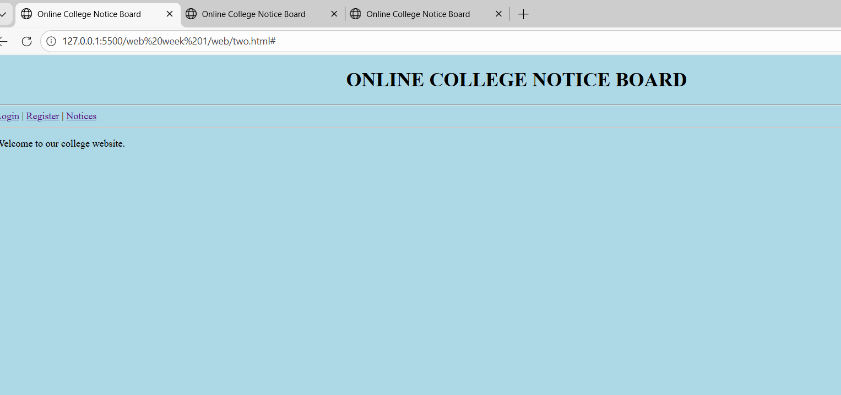
Login.html
<!DOCTYPE html>
<html>
<head>
<title>Login</title>
</head>
<body bgcolor="lightyellow">
<h2>Login Page</h2>
<form>
Username: <input type="text"><br><br>
Password: <input type="password"><br><br>
<input type="submit" value="Login">
</form>
<br>
<a href="two.html">Back to Home</a>
</body>
</html>
Op:
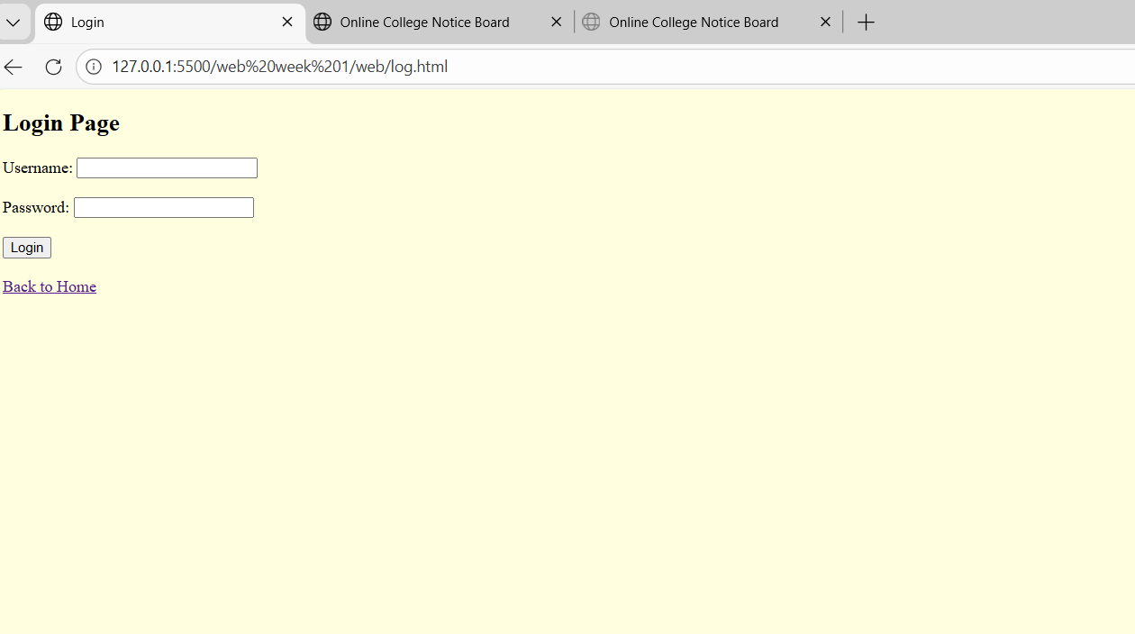
Register.Html:
<!DOCTYPE html>
<html>
<head>
<title>Register</title>
</head>
<body bgcolor="lightgreen">
<h2>Registration Page</h2>
<form>
Name: <input type="text"><br><br>
Email: <input type="email"><br><br>
<input type="submit" value="Register">
<input type="reset" value="Reset">
</form>
<br>
<a href="two.html">Back to Home</a>
</body>
</html>
Op:
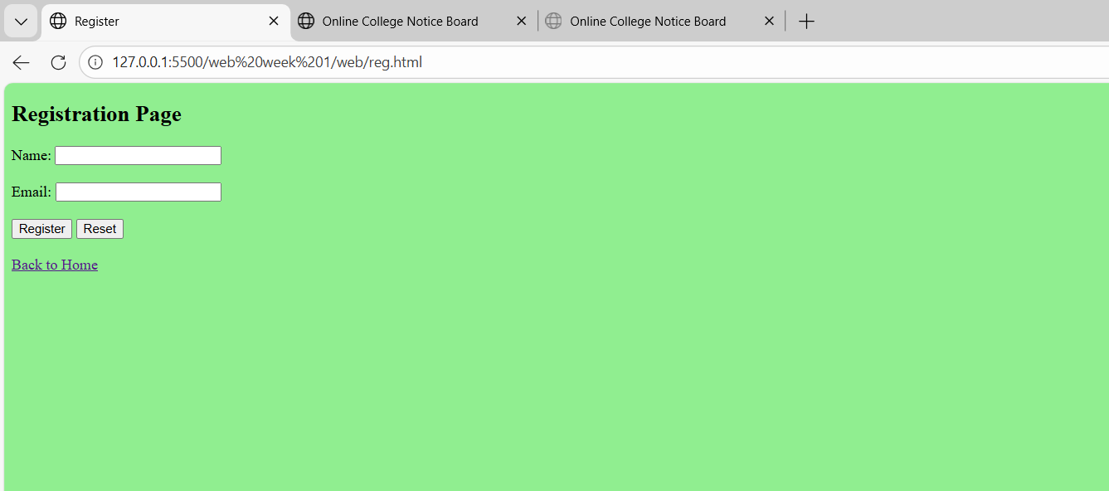
Catalogue.html
<!DOCTYPE html>
<html>
<head>
<title>Notices</title>
</head>
<body>
<h2>College Notices</h2>
<ul>
<li>Wear ID Card</li>
<li>Maintain Discipline</li>
</ul>
<ol>
<li>Internal Exam</li>
<li>Sports Day</li>
</ol>
<table border="1">
<tr>
<th>Name</th>
<th>Department</th>
</tr>
<tr>
<td>Anu</td>
<td>CSE</td>
</tr>
</table>
<br>
<a href="two.html">Back to Home</a>
</body>
</html>
Op:
